
Medicaid and Specialized Transportation Services Tips
The following is a tip guide based on Centers for Medicare and Medicaid Services (CMS) approved requirements for reimbursement of specialized transportation:
- Transportation must be provided by local education agencies/public schools
Covered services include:
- Special education transportation must be documented in student’s IEP.
- Drivers and vehicles must be employed through the school or have a contract with the school; and
- Meet applicable federal and state statutes and regulations for transporting students.
- Reimbursed on days when the student receives a “health related” or “medically necessary” service
- Covered “health related” or “medically necessary” service must be in student’s IEP
Documentation requirements
- Transportation must be in the student’s IEP.
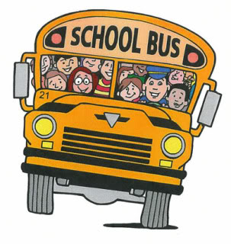
- Each trip must be documented on a bus log.
Must include the following information on Transportation Log
Date of Service, Student’s First and Last Name, School, Bus Number, and Type of Encounter: To/From
- Staff documenting trip must observe student’s arrival or departure on the bus. Have bus logs prepared for all schools to be used for the school year.
- Recommend daily documentation of trips to ensure compliance.
- Documentation of the billable direct service that the student receives on the day the transportation has been billed. This is provided by related staff entering their services that they provide to students in the service portal.
- Each trip must be documented by school personnel or the bus driver. Bus trip logs must include signature of the staff person and the date signed. Make sure these logs are maintained in the district with original signatures in case of a district audit. These files should be maintained for 7 years.

