
District ADMIN/ ISD ADMIN Plus Manage Students - Updating Parental Consent
You can update a student’s parental consent information directly in the Service Portal.
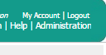
Begin by logging into the Service Portal www.meduclaim.com/serviceportal
Click on “Administration” in the top right corner of the page
Click on “Manage Students”
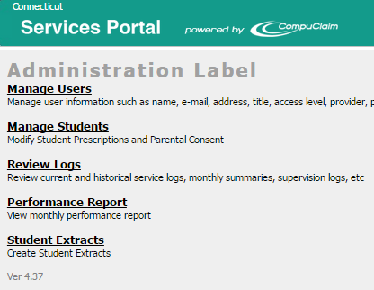
- Search for student by Last Name and First Name
- Click on search
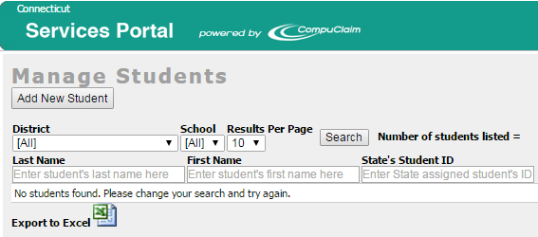
- Click the “edit” button on the left side of the screen.
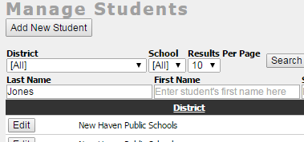

Parental consent is already defaulted to yes.
You can enter a date and indicate a “yes” or “no.
Parental consent, Parent notification, Prescriptions, and the comments section are the only fields you have access to document information on this page.
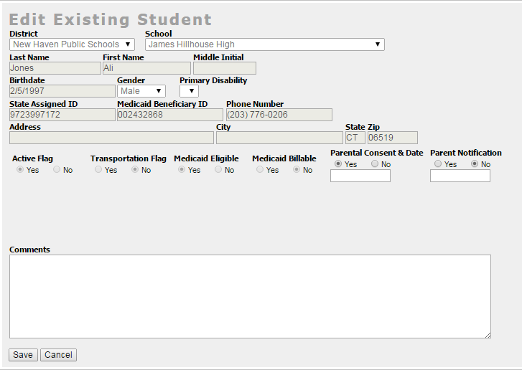
Once you have entered a date click the “save” button at the bottom of the page.

